Experiment – 1
Solve 8 Puzzle program

Aim:
To develop a Python program to solve the 8-Puzzle problem using the Breadth-First Search (BFS) algorithm and find the shortest sequence of moves from the initial state to the goal state.
Objective:
- To represent the 8-puzzle problem using a 3×3 matrix.
- To implement the Breadth-First Search (BFS) algorithm in Python.
- To find the shortest sequence of moves from the initial state to the goal state.
- To demonstrate state-space search and problem-solving techniques in Artificial Intelligence.
Algorithm:
- Start the program.
- Define the goal state of the 8-puzzle.
- Read the initial state from the user.
- Create an empty queue and insert the initial state into it.
- Create an empty visited set to store explored states.
- Repeat until the queue is empty
- If the queue becomes empty and the goal state is not reached, display "No solution found."
- End the program.

Code:
from collections import deque
goal = [[1,2,3],
[4,5,6],
[7,8,0]]

def find_zero(state):
for i in range(3):
for j in range(3):
if state[i][j] == 0:
return i, j
def neighbors(state):
x, y = find_zero(state)
moves = [(-1,0),(1,0),(0,-1),(0,1)]
result = []
for dx, dy in moves:
nx, ny = x + dx, y + dy
if 0 <= nx < 3 and 0 <= ny < 3:
new = [row[:] for row in state]
new[x][y], new[nx][ny] = new[nx][ny], new[x][y]
result.append(new)
return result
def bfs(start):
queue = deque([(start, [])])
visited = [
while queue:
state, path = queue.popleft()
if state == goal:
return path + [state]

if state not in visited:
visited.append(state)
for next_state in neighbors(state):
queue.append((next_state, path + [state]))
return None

# Example
start = [[1,2,3],
[4,0,6],
[7,5,8]]

solution = bfs(start)
if solution:
print("Solution Steps:")
for step in solution:
for row in step:
print(row)
print()
else:
print("No Solution")

Output:
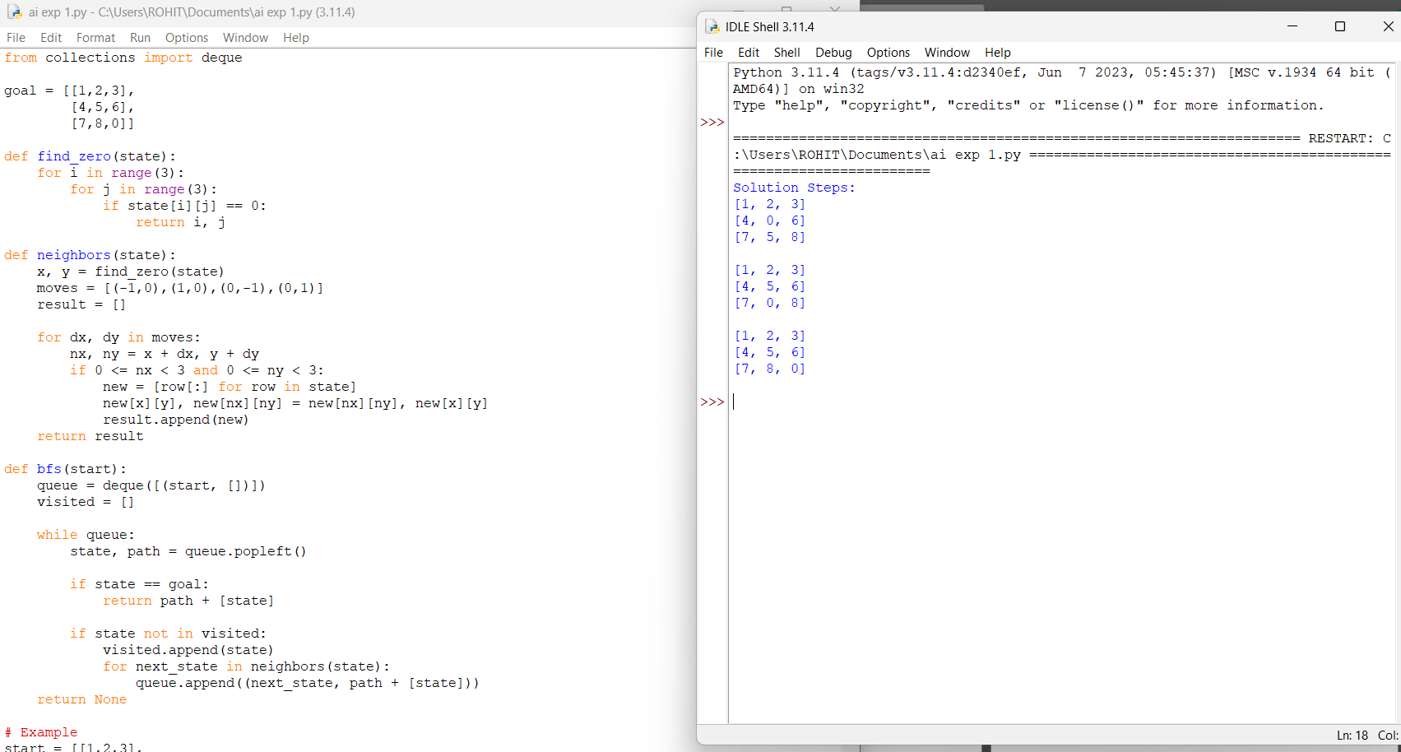

Result:
The 8-Puzzle problem was successfully solved using the Breadth-First Search (BFS) algorithm, and the shortest path from the initial state to the goal state was obtained.
Conclusion:
The 8-Puzzle problem was successfully solved using the Breadth-First Search (BFS) algorithm, demonstrating its effectiveness in finding the shortest path to the goal state.

Experiment-2
To Solve 8 Queen Problem
Aim:
To develop a Python program to solve the 8-Queens Problem using the Backtracking algorithm.
Objective
- To solve the 8-Queens problem using Backtracking.
- To place eight queens on an 8×8 chessboard without attacking each other.
- To understand constraint satisfaction problems in Artificial Intelligence.
Algorithm
- Start the program.
- Initialize an empty 8×8 chessboard.
- Place a queen in the first column.
- Check if the queen placement is safe (no two queens share the same row, column, or diagonal).
- If safe, place the queen and move to the next column.
- If no safe position is found, backtrack and move the previous queen.
- Repeat until all eight queens are placed.
- Display the final board configuration.
- Stop the program.

Code:
N = 8

def safe(board, row, col):
for i in range(row):
if board[i] == col or abs(board[i] - col) == abs(i - row):
return False
return True

def solve(board, row):
if row == N:
print(board)
return
for col in range(N):
if safe(board, row, col):
board[row] = col
solve(board, row + 1)

board = [-1] * N
solve(board, 0)Output:

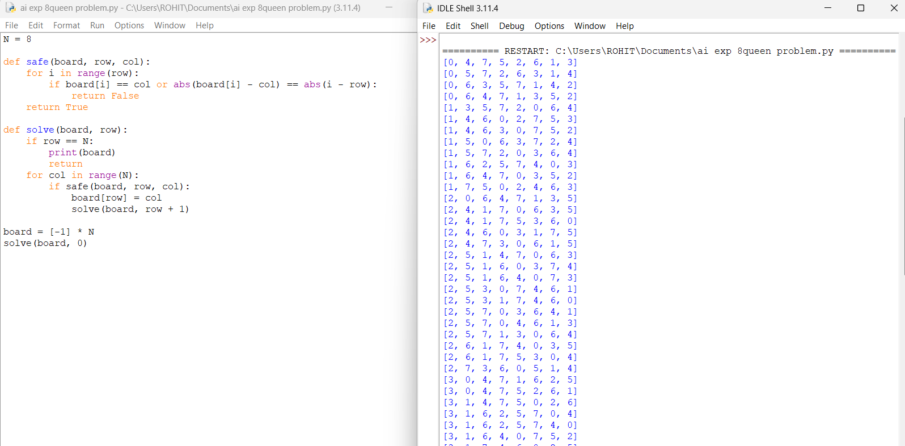

Result:
The 8-Queens problem was successfully solved using the Backtracking algorithm, and a valid arrangement of eight queens was obtained.
Conclusion:
The Backtracking algorithm efficiently solved the 8-Queens problem by placing queens without conflicts, demonstrating its effectiveness for constraint satisfaction problems in Artificial Intelligence.

Experiment-3
Water Jug Problem
Aim
To develop a Python program to solve the Water Jug Problem using the Breadth-First Search (BFS) algorithm.

Objective
- To solve the Water Jug Problem using BFS.
- To obtain the desired amount of water using two jugs of different capacities.
- To understand state-space search techniques in Artificial Intelligence.

Algorithm
- Start the program.
- Define the capacities of the two water jugs and the target quantity.
- Initialize the starting state with both jugs empty.
- Create a queue and a visited set.
- Remove a state from the queue.
- Check whether the target quantity is reached.
- If reached, display the solution and stop.
- Otherwise, generate all possible next states by filling, emptying, or pouring water between the jugs.
- Add unvisited states to the queue.
- Repeat until the target is found or all states are explored.
- Stop the program.

Code:
from collections import deque

def water_jug(cap1, cap2, target):
visited = set()
queue = deque([(0, 0)])

while queue:
x, y = queue.popleft()

if (x, y) in visited:
continue
visited.add((x, y))

print((x, y))

if x == target or y == target:
print("Target Reached!")
return

next_states = [
(cap1, y), # Fill Jug 1
(x, cap2), # Fill Jug 2
(0, y), # Empty Jug 1
(x, 0), # Empty Jug 2
(max(0, x-(cap2-y)), min(cap2, x+y)), # Pour Jug1 -> Jug2
(min(cap1, x+y), max(0, y-(cap1-x))) # Pour Jug2 -> Jug1
]

for state in next_states:
if state not in visited:
queue.append(state)

# Example
water_jug(4, 3, 2)Output:
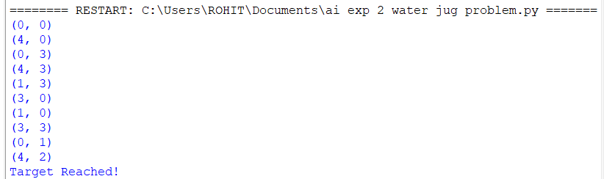
Result:
The Water Jug Problem was successfully solved using the Breadth-First Search (BFS) algorithm, and the required quantity of water was obtained.

Conclusion:
The Breadth-First Search (BFS) algorithm efficiently solved the Water Jug Problem by finding the shortest sequence of operations to reach the target state.

Experiment-4
Cript-Arithmetic Problem
Aim:
To develop a Python program to solve the Cryptarithmetic Problem using Backtracking.
Objective:
- To solve a cryptarithmetic puzzle using Backtracking.
- To assign unique digits to letters while satisfying the arithmetic equation.
- To understand constraint satisfaction techniques in Artificial Intelligence.
Algorithm:
- Start the program.
- Define the letters in the cryptarithmetic puzzle.
- Generate all possible digit assignments.
- Ensure each letter has a unique digit.
- Do not allow leading letters to be zero.
- Form the numbers represented by the words
Code:
from itertools import permutations
letters = ('S','E','N','D','M','O','R','Y')
digits = (0,1,2,3,4,5,6,7,8,9)
for p in permutations(digits, 8):
d = dict(zip(letters, p))
# First letters cannot be zero
if d['S'] == 0 or d['M'] == 0:
continu
SEND = 1000*d['S'] + 100*d['E'] + 10*d['N'] + d['D']
MORE = 1000*d['M'] + 100*d['O'] + 10*d['R'] + d['E']
MONEY = 10000*d['M'] + 1000*d['O'] + 100*d['N'] + 10*d['E'] + d['Y'
if SEND + MORE == MONEY:
print("SEND =", SEND)
print("MORE =", MORE)
print("MONEY =", MONEY)
break
Output:
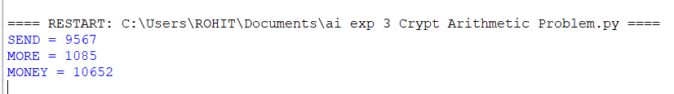

Result:
The Cryptarithmetic Problem was successfully solved using the Backtracking algorithm, and a valid digit assignment satisfying the equation was obtained.

Experiment-5
Aim:
To develop a Python program to solve the Missionaries Left, Cannibals algorithm.
Objective
- To solve the Missionaries Left, Cannibalsproblem using Backtracking.
- To understand constraint satisfaction problems in Artificial Intelligence.
Algorithm
- Start the program.
- Display the final board configuration.
- Stop the program.

Code:
from collections import deque

def is_valid(m_left, c_left):
m_right = 3 - m_left
c_right = 3 - c_left

if m_left > 0 and m_left < c_left:
return False
if m_right > 0 and m_right < c_right:
return False
return True

def bfs():
start = (3, 3, 1) # (Missionaries Left, Cannibals Left, Boat)
goal = (0, 0
queue = deque([(start, []
moves = [(1,0), (2,0), (0,1), (0,2), (1,1)]
while queue:
state, path = queue.popleft()
if state == goal:
return path + [state
if state in visited:
continue
visited.add(state)

m, c, boat = state

for dm, dc in moves:
if boat == 1: # Boat on left
new = (m-dm, c-dc, 0)
else: # Boat on right
new = (m+dm, c+dc, 1)

nm, nc, nb = new

if 0 <= nm <= 3 and 0 <= nc <= 3:
if is_valid(nm, nc):
queue.append((new, path + [state]))

solution = bfs()

print("Solution:")
for step in solution:
print(step)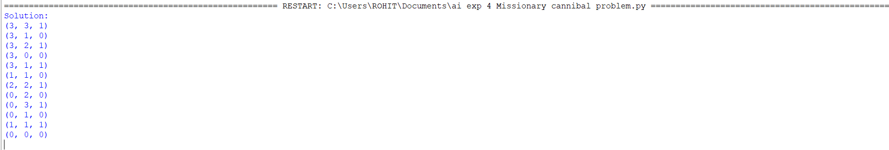

Result:
The 8-Queens problem was successfully solved using the Backtracking algorithm, and a valid arrangement of eight queens was obtained.
Conclusion:
The Backtracking algorithm efficiently solved the 8-Queens problem by placing queens without conflicts, demonstrating its effectiveness for constraint satisfaction problems in Artificial Intelligence.

Experiment-6
Vacuum Cleaner Problem
Aim:
To develop a Python program to solve the Vacuum Cleaner Problem using a Simple Reflex Agent in Artificial Intelligence.

Objective:
- To simulate the working of a vacuum cleaner agent.
- To clean all dirty rooms using simple decision rules.
- To understand the concept of intelligent agents in Artificial Intelligence.

Algorithm:
- Start the program.
- Initialize the rooms as dirty.
- Place the vacuum cleaner in the first room.
- Check the current room.
- If the room is dirty, clean it.
- Otherwise, move to the other room.
- Repeat until all rooms are clean.
- Display that all rooms are clean.
- Stop the program.
Code:
# Vacuum Cleaner Problem

rooms = {'A': 'Dirty', 'B': 'Dirty'}
location = 'A'

while True:
if rooms[location] == 'Dirty':
print("Vacuum is in Room", location)
print("Room", location, "is Dirty -> Cleaning...")
rooms[location] = 'Clean'
else:
print("Room", location, "is already Clean")

if location == 'A':
location = 'B'
else:
break

print("\nFinal Room Status:")
for room in rooms:
print(room, ":", rooms[room])

Output:
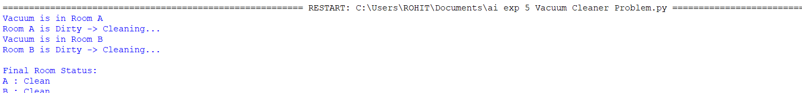

Result:
The Vacuum Cleaner Problem was successfully solved using a Simple Reflex Agent, and all dirty rooms were cleaned.

Conclusion:
The Vacuum Cleaner Agent efficiently cleaned all rooms by following simple condition-based rules, demonstrating the basic concept of intelligent agents in Artificial Intelligence.

Experiment-7
Program to Implement BFS
Aim
To develop a Python program to implement the Breadth-First Search (BFS) algorithm for graph traversal.

Objective
- To implement the Breadth-First Search (BFS) algorithm.
- To traverse all nodes of a graph level by level.
- To understand graph traversal techniques in Artificial Intelligence.

Algorithm
- Start the program.
- Create the graph using an adjacency list.
- Initialize an empty visited set.
- Insert the starting node into a queue.
- Remove the front node from the queue.
- If the node is not visited, mark it as visited and display it.
- Repeat until the queue becomes empty.
- Stop the program.

Code:
from collections import deque
# BFS function
def bfs(graph, start):
visited = set() # To keep track of visited nodes
queue = deque([start]) # Initialize queue with the start node
visited.add(start)

print("BFS Traversal:", end=" ")

while queue:
node = queue.popleft()
print(node, end=" ")

# Visit all unvisited neighbors
for neighbor in graph[node]:
if neighbor not in visited:
visited.add(neighbor)
queue.append(neighbor
# Example graph represented as an adjacency list
graph = {
'A': ['B', 'C'],
'B': ['A', 'D', 'E'],
'C': ['A', 'F'],
'D': ['B'],
'E': ['B', 'F'],
'F': ['C', 'E']
}

# Starting BFS from node 'A'
bfs(graph, 'A')
Output:

Result:
The Breadth-First Search (BFS) algorithm was successfully implemented, and all graph nodes were traversed in level-order.

Conclusion:
The Breadth-First Search (BFS) algorithm efficiently traverses a graph level by level using a queue, ensuring that all reachable nodes are visited systematically.
Experiment-8
Program to Implement DFS
Aim
To develop a Python program to implement the Depth-First Search (DFS) algorithm for graph traversal.

Objective
- To implement the Depth-First Search (DFS) algorithm.
- To traverse all nodes of a graph using depth-first traversal.
- To understand graph traversal techniques in Artificial Intelligence.

Algorithm
- Start the program.
- Create the graph using an adjacency list.
- Initialize an empty visited set.
- Start DFS from the source node.
- Mark the current node as visited and display it.
- Recursively visit all unvisited adjacent nodes.
- Repeat until all reachable nodes are visited.
- Stop the program.

Code:
# DFS function
def dfs(graph, node, visited):
visited.add(node)
print(node, end=" ")

for neighbor in graph[node]:
if neighbor not in visited:
dfs(graph, neighbor, visited)

# Graph
graph = {
'A': ['B', 'C'],
'B': ['A', 'D', 'E'],
'C': ['A', 'F'],
'D': ['B'],
'E': ['B', 'F'],
'F': ['C', 'E']
}

# Start DFS from A
visited = set()
print("DFS Traversal:", end=" ")
dfs(graph, 'A', visited)
Output:

Result:
The Depth-First Search (DFS) algorithm was successfully implemented, and all graph nodes were traversed in depth-first order.

Conclusion:
The Depth-First Search (DFS) algorithm efficiently traverses a graph by exploring each branch completely before backtracking, making it suitable for graph search and traversal problems.

Experiment-9
To Implement Travelling Salesman Problem
Aim
To develop a Python program to solve the Travelling Salesman Problem (TSP) using the Brute Force approach.

Objective
- To implement the Travelling Salesman Problem (TSP).
- To find the minimum cost path that visits every city exactly once and returns to the starting city.
- To understand optimization techniques in Artificial Intelligence.

Algorithm
- Start the program.
- Define the distance matrix for all cities.
- Generate all possible routes using permutations.
- Calculate the total cost of each route.
- Compare the route cost with the minimum cost.
- Update the minimum cost if a shorter route is found.
- Display the minimum travel cost.
- Stop the program.

Code:
from itertools import permutations

dist = [
[0, 10, 15, 20],
[10, 0, 35, 25],
[15, 35, 0, 30],
[20, 25, 30, 0]
]

n = len(dist)
cities = range(1, n)

min_cost = float('inf')
best_path = None

for p in permutations(cities):
path = (0,) + p + (0,)
cost = sum(dist[path[i]][path[i+1]] for i in range(n))

if cost < min_cost:
min_cost = cost
best_path = path

print("Best Path:", best_path)
print("Minimum Cost:", min_cost)
Output:

Result:
The Travelling Salesman Problem (TSP) was successfully solved, and the minimum travel cost was obtained.

Conclusion:
The Travelling Salesman Problem was solved by evaluating all possible routes and selecting the one with the minimum travel cost.
Experiment-10
Program to Implement A* Algorithm
Aim
To develop a Python program to implement the A* Search Algorithm for finding the shortest path.

Objective
- To implement the A* Search Algorithm.
- To find the shortest path between the start and goal nodes.
- To understand heuristic-based search techniques in Artificial Intelligence.

Algorithm
- Start the program.
- Define the graph and heuristic values.
- Add the start node to the open list.
- Select the node with the lowest f(n) = g(n) + h(n) value.
- If the goal node is reached, display the cost.
- Otherwise, expand the selected node.
- Update the open list with neighboring nodes.
- Repeat until the goal is reached.
- Stop the program.

Code:
graph = {
'A': {'B': 1, 'C': 3},
'B': {'D': 5, 'E': 2},
'C': {'F': 4},
'D': {},
'E': {'G': 1},
'F': {'G': 2},
'G': {}
}

h = {'A':7, 'B':6, 'C':4, 'D':5, 'E':2, 'F':2, 'G':0}

open = [('A', 0)]
visited = {}

while open:
open.sort(key=lambda x: x[1] + h[x[0]])
node, cost = open.pop(0)

if node == 'G':
print("Cost =", cost)
break

if node not in visited:
visited[node] = cost
for n, c in graph[node].items():
open.append((n, cost + c))

Output:
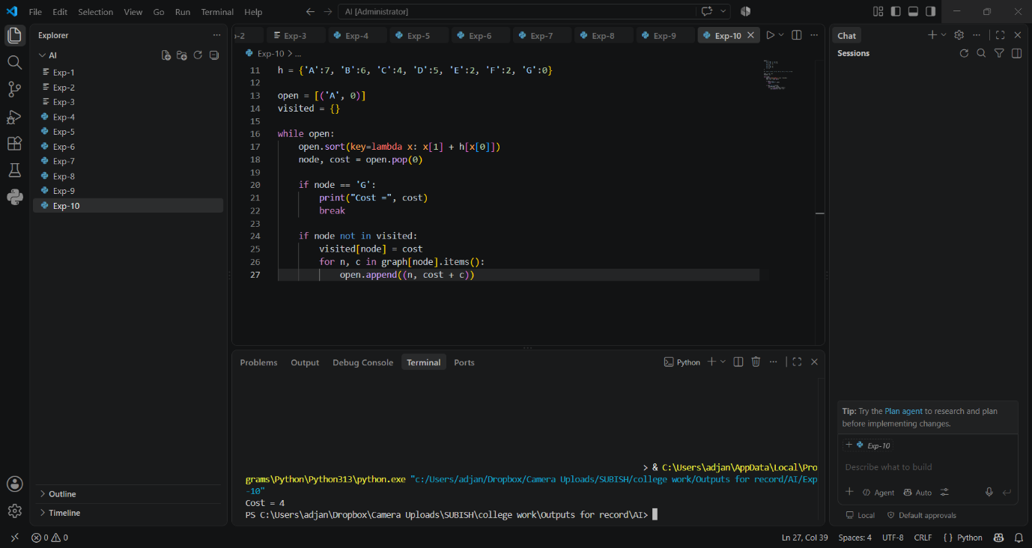

Result:
The A* algorithm was successfully implemented and found the shortest path to the goal node.

Conclusion:
The A* algorithm efficiently finds the shortest path by combining the actual path cost and heuristic estimate, making it one of the most effective informed search algorithms in Artificial Intelligence.
Experiment-11
Write the Python Program for map Colouring to Implement CSP

AIM
To implement the Map Coloring Problem using Constraint Satisfaction Problem (CSP) in Python using the backtracking technique.
Objective
- To implement the Map Coloring Problem using CSP.
- To assign colors to map regions while satisfying the given constraints.
- To understand Constraint Satisfaction Problems in Artificial Intelligence.
Algorithm
- Start the program.
- Define the map as a graph with neighboring regions.
- Define the available colors.
- Select an uncolored region.
- Assign a color that does not conflict with its neighboring regions.
- If no valid color is available, backtrack and try another color.
- Stop the program.

Code:
colors = ['Red', 'Green', 'Blue']
graph = {
'A': ['B', 'C'],
'B': ['A', 'C', 'D'],
'C': ['A', 'B', 'D'],
'D': ['B', 'C']
}

color = {}
def valid(node, c):
for neighbor in graph[node]:
if neighbor in color and color[neighbor] == c:
return False
return True
def solve():
if len(color) == len(graph):
return True
node = next(n for n in graph if n not in color)
for c in colors:
if valid(node, c):
color[node] = c
if solve():
return True
del color[node]
return False
solve()
print("Map Coloring:")
for node in color:
print(node, ":", color[node])

Output:

Result:
The Map Coloring Problem was successfully implemented using Constraint Satisfaction Problem (CSP) and valid colors were assigned to all regions without conflicts.
Conclusion:
The Map Coloring problem was successfully implemented using CSP. The program assigns colors to different regions while satisfying the constraint that adjacent regions must have different colors.

Experiment-12
Python Program for Tic Tac Toe Game
Aim
To develop a Python program to implement a Tic-Tac-Toe game for two players.
Objective
- To implement a two-player Tic-Tac-Toe game using Python.
- To check the winning conditions after each move.
- To display the winner or draw result.
Algorithm
- Start the program.
- Initialize a 3×3 game board.
- Display the board.
- Select the current player (X or O).
- Get the position from the player
- Otherwise, switch the player and repeat.
- Stop the program.

Code:
board = [' '] * 9
def show():
print(board[0], '|', board[1], '|', board[2])
print('--+---+--')
print(board[3], '|', board[4], '|', board[5])
print('--+---+--')
print(board[6], '|', board[7], '|', board[8])
def win(p):
lines = [
(0,1,2), (3,4,5), (6,7,8),
(0,3,6), (1,4,7), (2,5,8),
(0,4,8), (2,4,6)
]
return any(board[a] == board[b] == board[c] == p
for a,b,c in lines)
for turn in range(9):
show()
p = 'X' if turn % 2 == 0 else 'O'
pos = int(input(p + " position (1-9): ")) - 1
if board[pos] == ' ':
board[pos] = p
else:
print("Position already used!")
continu
if win(p):
show()
print(p, "wins!")
break
else:
show()
print("Draw!")
Output: 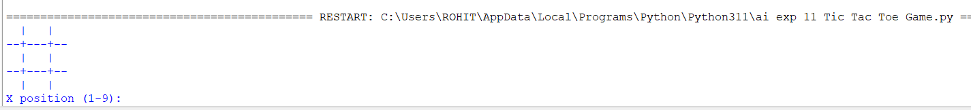

Result
The Tic-Tac-Toe game was successfully implemented in Python, and the program correctly identifies the winner or draw.
Conclusion
The Tic-Tac-Toe game was successfully developed using Python. The program demonstrates the use of lists, functions, loops, conditions, and user input to implement a simple game.

Experiment-13
To Implement Minimax Algorithm for Gaming
Aim
To implement the Minimax Algorithm for a two-player gaming problem using Python.
Objective
- To implement the Minimax Algorithm.
- To find the best possible move for a player.
- To understand decision-making in two-player games.
Algorithm
- Start the program.
- Initialize the game board.
- Check whether the game is over.
- If the maximizing player is playing, select the maximum score.
- If the minimizing player is playing, select the minimum score.
- Recursively evaluate all possible moves.
- Select the best move based on the score.
- Display the best move.
- Stop the program.

Code:
def minimax(depth, maximizing):
scores = [10, -10, 0]

if depth == 0:
return scores[0]

if maximizing:
best = -1000
for score in scores:
best = max(best, score)
return best
else:
best = 1000
for score in scores:
best = min(best, score)
return best

print("Best Score:", minimax(1, True))
Output:
Result
The Minimax Algorithm was successfully implemented in Python to determine the best possible move in a two-player game.
Conclusion
The Minimax Algorithm helps a player make the optimal decision by evaluating possible future moves and selecting the best outcome.

14 Alpha & Beta Pruning Algorithm for Gaming
Aim: To implement the Alpha-Beta pruning algorithm using Python.
Algorithm:
- Start.
- Initialize alpha to -infinity and beta to +infinity.
- At the maximizer's turn, update alpha and prune if beta <= alpha.
- At the minimizer's turn, update beta and prune if beta <= alpha.
- Recurse until the maximum depth or a terminal node is reached.
- Return the optimal value while skipping branches that cannot influence the result.
- Stop.
CODE
def alphabeta(depth, alpha, beta, maximizing):
if depth == 0:
return 10
if maximizing:
best = -1000
for i in range(2):
value = alphabeta(depth - 1, alpha, beta, False)
best = max(best, value)
alpha = max(alpha, best)
if beta <= alpha:
break
return best
else:
best = 1000
for i in range(2):
value = alphabeta(depth - 1, alpha, beta, True)
best = min(best, value)
beta = min(beta, best)
if beta <= alpha:
break
return best
result = alphabeta(3, -1000, 1000, True
print("Best Value:", result)

output :

Result
Thus, the Alpha-Beta pruning algorithm for gaming was implemented successfully using Python.
15. Decision Tree
Aim: To implement a Decision Tree classifier using Python.
Algorithm:
- Start.
- Prepare the training dataset with features and class labels.
- Select the best attribute to split the data using entropy/information gain.
- Create a decision node and split the dataset accordingly.
- Repeat recursively for each branch until a stopping criterion is met.
- Use the trained tree to classify new/unseen samples.
- Stop.
CODE:
from sklearn.tree import DecisionTreeClassifier
# [Hours studied, Attendance]
X = [
[2, 60],
[3, 65],
[5, 75],
[6, 80],
[8, 90],
[9, 95]
]
# 0 = Fail, 1 = Pass
y = [0, 0, 1, 1, 1, 1]
model = DecisionTreeClassifier()
model.fit(X, y)

hours = float(input("Enter study hours: "))
attendance = float(input("Enter attendance: "))
result = model.predict([[hours, attendance]]
if result[0] == 1:
print("Result: Pass")
else:
print("Result: Fail")

output :
Pass
Result
Thus, the Decision Tree classifier was implemented successfully using Python.

16 Feed Forward Neural Network
Aim: To implement a Feed Forward Neural Network using Python.
Algorithm:
- Start.
- Initialize the input dataset and random weights.
- Perform forward propagation using the sigmoid activation function.
- Compute the error between predicted and actual output.
- Perform backpropagation to update the weights.
- Repeat for a fixed number of epochs.
- Display the final predicted output.
- Stop.
CODE:
from sklearn.neural_network import MLPClassifier
# AND gate
X = [
[0, 0],
[0, 1],
[1, 0],
[1, 1]

y = [0, 0, 0, 1]
model = MLPClassifier(
hidden_layer_sizes=(4,),
max_iter=2000,
random_state=1

model.fit(X, y
for x in X:
print(x, "=>", model.predict([x])[0])

output
[0, 0] => 0
[0, 1] => 0
[1, 0] => 0
[1, 1] => 0

Result
Thus, the Feed Forward Neural Network was implemented successfully using Python.

